**MapKit Tutorial -** Watch Podcast: <http://www.youtube.com/watch?v=1ak_94iqffY>

1. Create **New Single View Application**, **Product Name:** CrimeMap  
   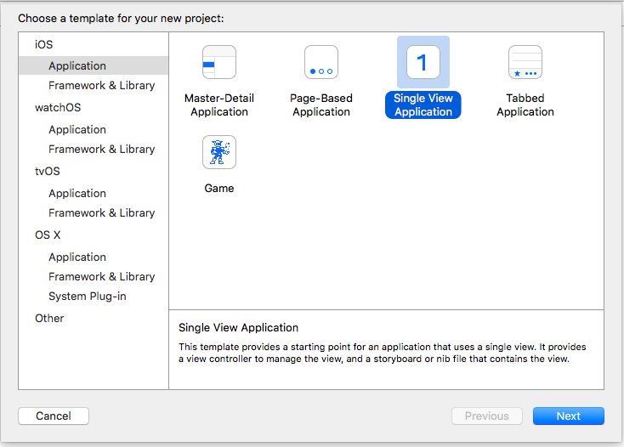  
   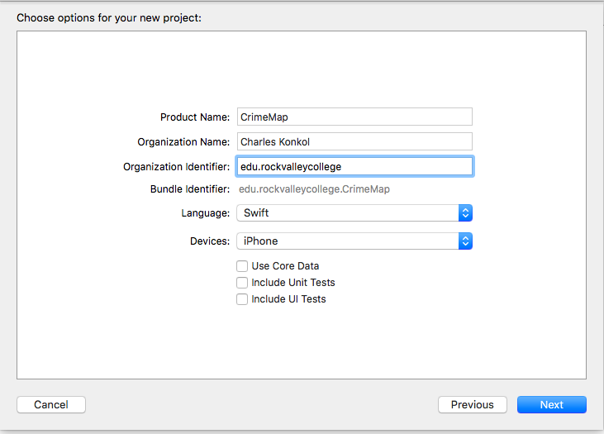
2. Set Device Orientation to **Portrait**
3. Select **Main.Storyboard**
4. Hide Document Outline  
   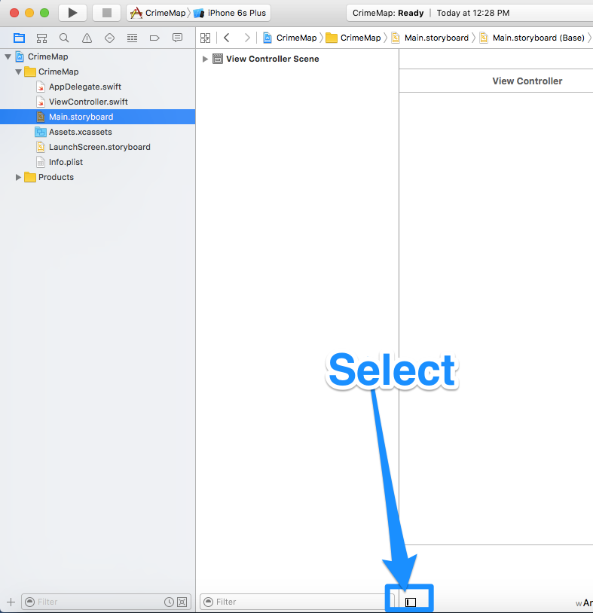
5. Add Objects to View Controller
   * Navigation Bar. Change **Title** to **Rockford Crime Map**
   * 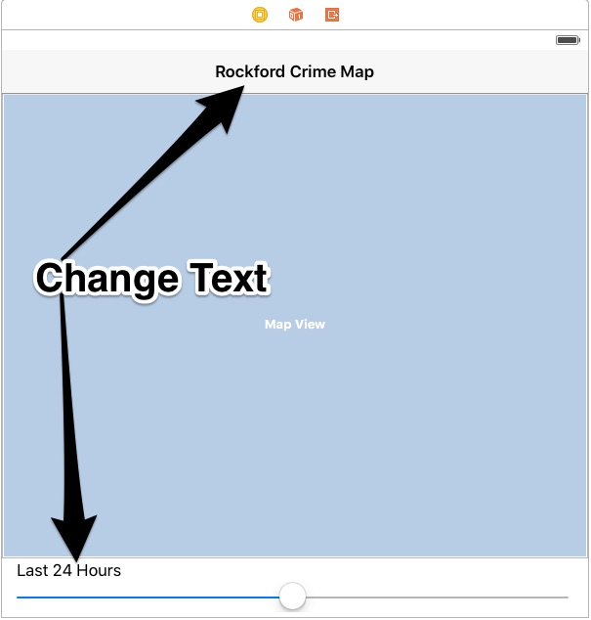Map Kit View
   * Label. Change **Label** to **Last 24 Hours**
   * UISlider  
     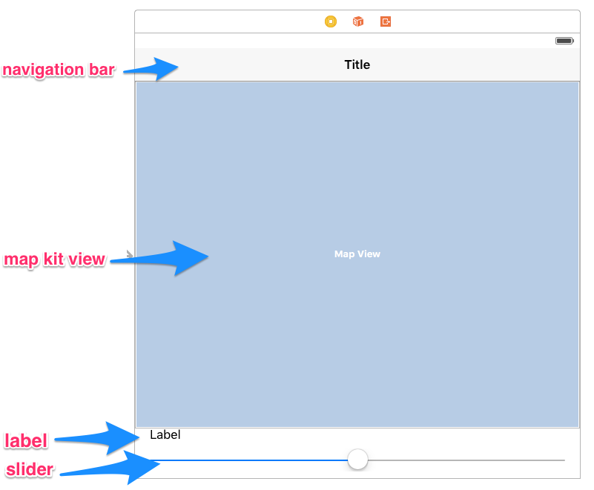
6. Click on viewcontroller.swift and add Imports to top of viewcontroller.swift

import MapKit

import Foundation

1. Click on Main.StoryBoard > Show Assistant Editor and Create Outlets & Actions (Click, Drag and Drop to Code)
   * Navigation Bar
     + Name: **navigationBar**
   * Map Kit View
     + Name: **mapView**
   * Label
     + Name: **lblCrimeRange**
   * Slider - 2 Action Events
     + Name: **DateSlider,** Type**: UISlider,** Event: **Value Changed**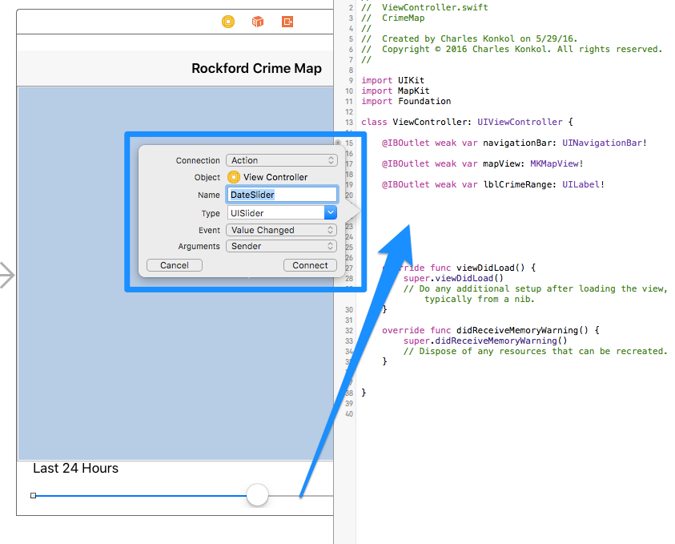
     + Name: **DateSliderUp,** Type**: UISlider,** Event: **Touch Up Inside**   
         
        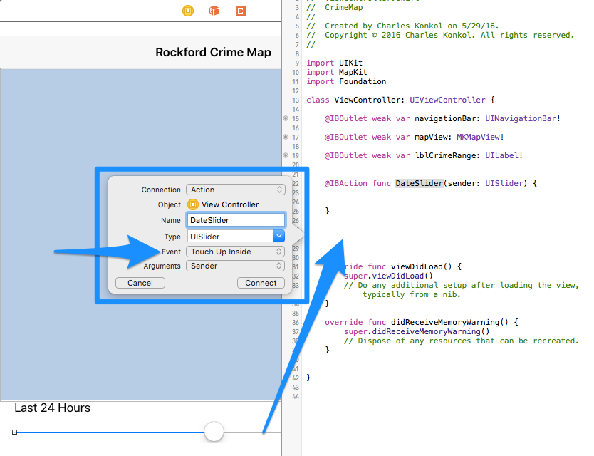
       - 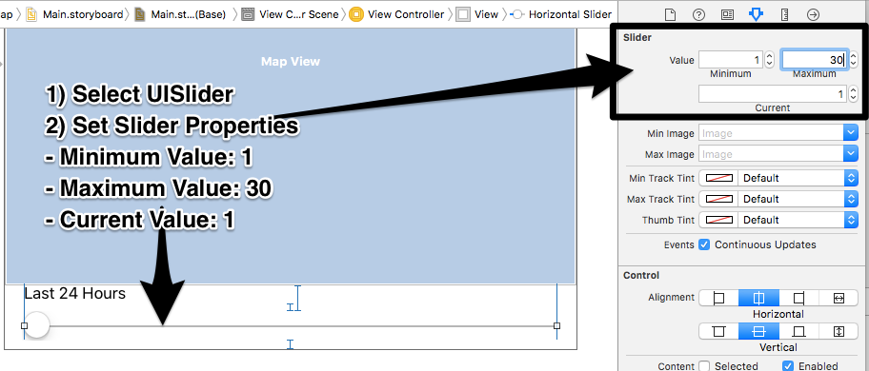
2. Add New Class
   * Control Click on **CrimeMap** folder and select **New File**
   * 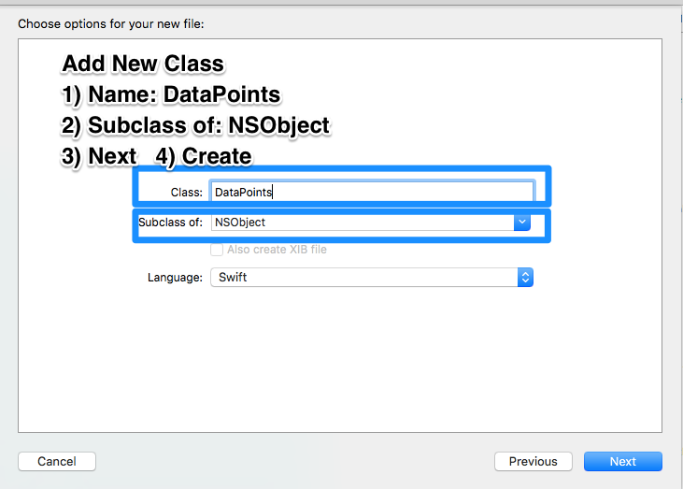
   * Class Name: **DataPoints,** Subclass: **NSObject**, Language: **Swift**
3. Add Code. Follow Commenst Steps in Code.   
   **Disregard errors until ALL Steps are completed in BOTH below files**
   * [ViewController.swift](https://github.com/ioscourse/CrimeMap/blob/master/ViewController.txt)
   * [DataPoints.swift](https://github.com/ioscourse/CrimeMap/blob/master/DataPoints.swift.txt)
4. Align Objects
   * Editor > Resolve Auto Layout Issues > Reset to Suggested Constraints
5. Test. [Command] + R
6. Add Icon
   * User Pixlr.com to create a 1024x1024
   * <https://makeappicon.com/>